Point Containment

Definition
# Source: AI Source: Provided by: [Data Path: Persons Table -> ID Column: 1, Name_En Column: Motasem Essam] -> From: [ChatGPT] on [7/25/2026]
Point Containment is a geometric relationship in which a point belongs to or lies within a geometric object.
If a point P belongs to a geometric object G, the relationship is written as:
$$\boxed{P∈G}$$
Point containment is one of the most fundamental forms of geometric containment because geometric objects are generally defined as sets of points.
A point may be:
- On a line
- On a segment
- On a ray
- On a plane
- Inside a region
- On the boundary of a region
- Inside a solid
- On a surface
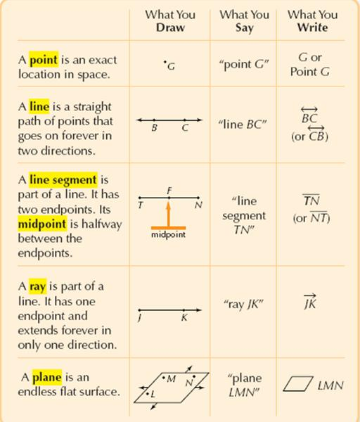
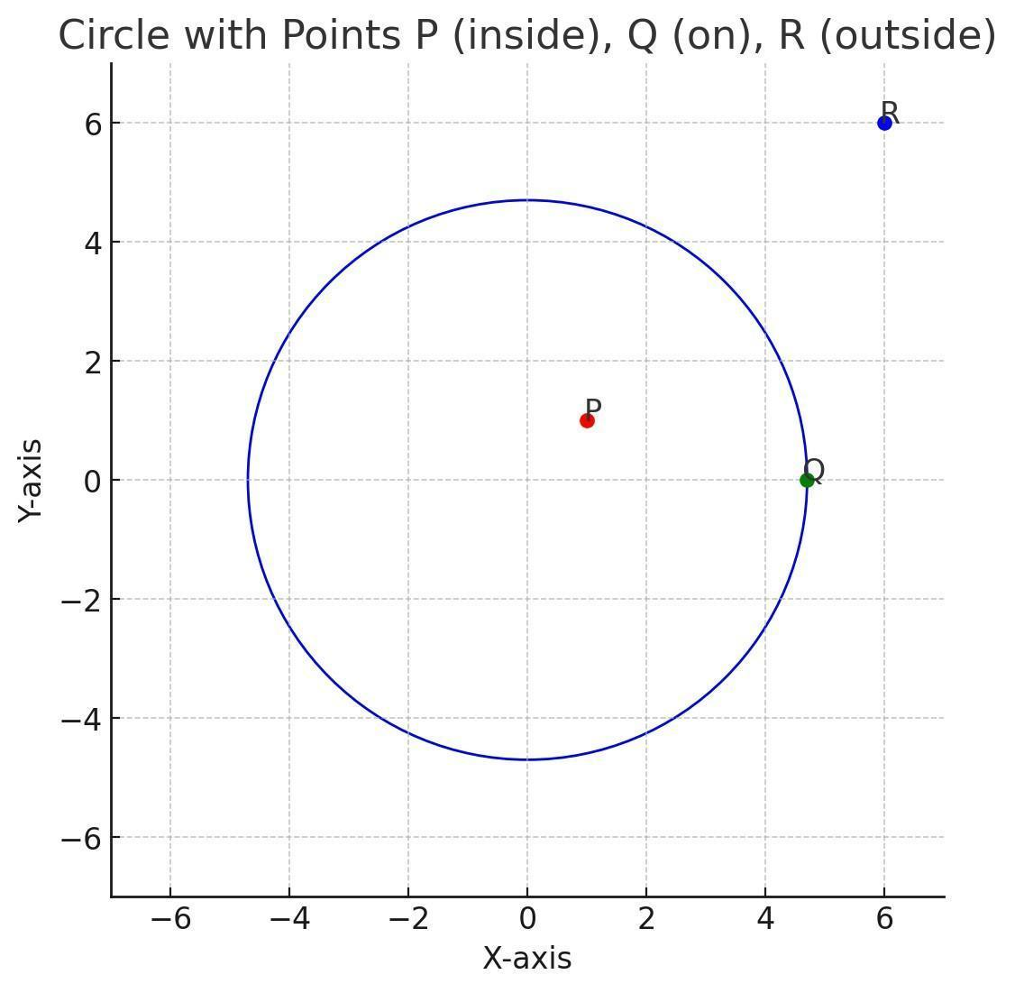
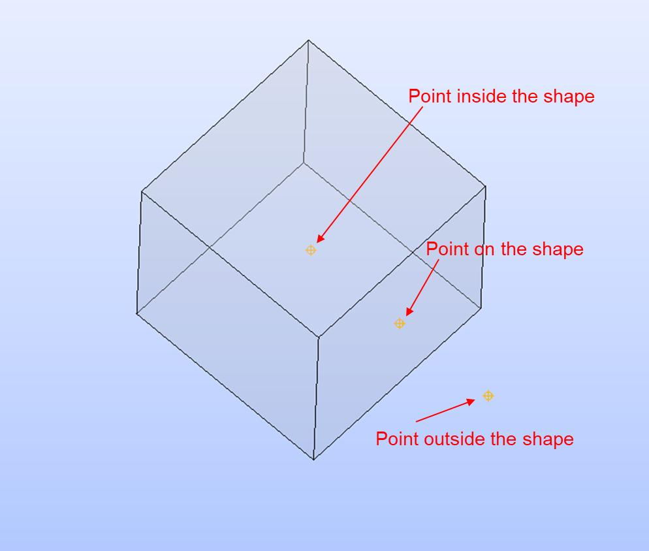
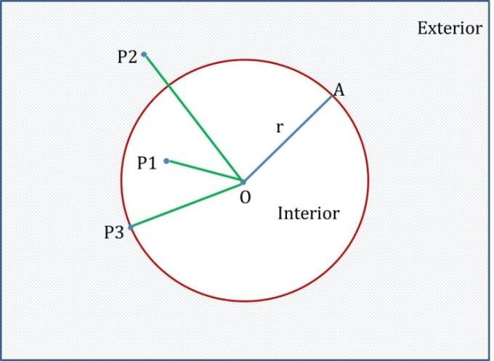
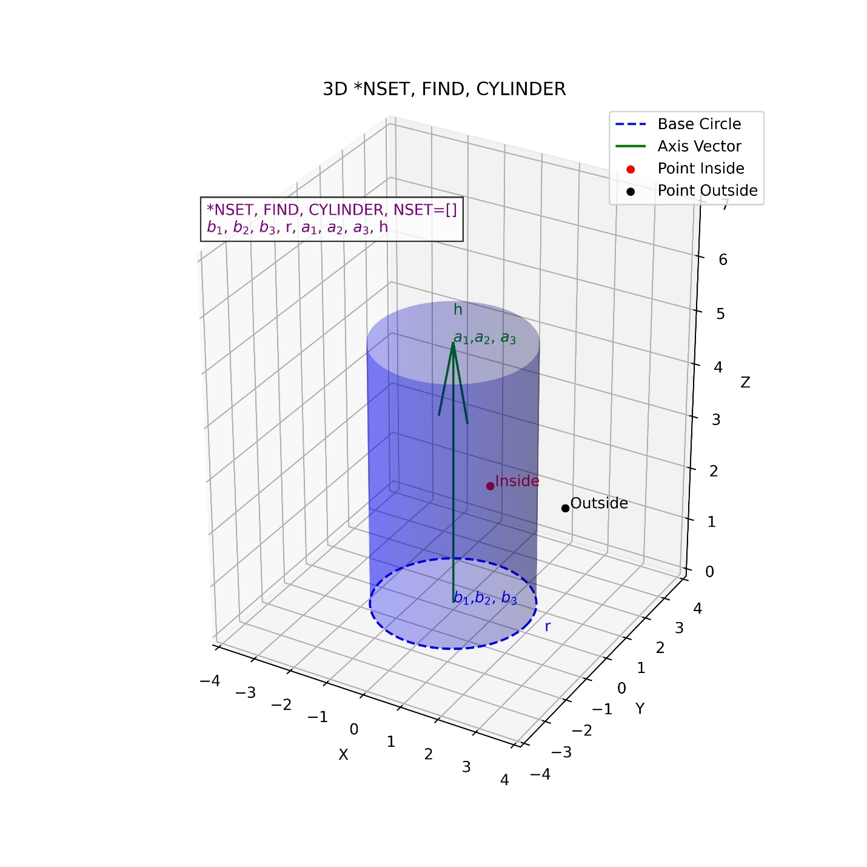

Purpose
# Source: AI Source: Provided by: [Data Path: Persons Table -> ID Column: 1, Name_En Column: Motasem Essam] -> From: [ChatGPT] on [7/25/2026]
Point containment is used to:
- Determine whether a point belongs to a geometric object.
- Describe the position of a point relative to a shape.
- Define lines, segments, planes, regions, and solids using sets of points.
- Test whether coordinates satisfy a geometric equation or inequality.
- Determine whether a point is inside, outside, or on the boundary of a region.
- Establish relationships between points and geometric objects.

Fundamental Concept
# Source: AI Source: Provided by: [Data Path: Persons Table -> ID Column: 1, Name_En Column: Motasem Essam] -> From: [ChatGPT] on [7/25/2026]
The central idea is membership.
If P is a point and G is a geometric object:
$$\boxed{P∈G}$$
means:
Point P is an element of geometric object G.
If the point does not belong to the object:
$$\boxed{P∉G}$$
For example, if:
$$P=\left(2 , 4\right)$$
lies on line:
$$y=2x$$
then:
$$4=2\left(2\right)$$
so:
$$\boxed{P∈l}$$

Types of Point Containment
# Source: AI Source: Provided by: [Data Path: Persons Table -> ID Column: 1, Name_En Column: Motasem Essam] -> From: [ChatGPT] on [7/25/2026]
Point containment can be classified according to the geometric object containing the point.

1. Point on a Line
# Source: AI Source: Provided by: [Data Path: Persons Table -> ID Column: 1, Name_En Column: Motasem Essam] -> From: [ChatGPT] on [7/25/2026]
A point is contained in a line if it lies somewhere on the infinite line.
For point P and line l:
$$\boxed{P∈l}$$
Example:
$$l:y=2x+1$$
and:
$$P=\left(3 , 7\right)$$
Check:
$$7=2\left(3\right)+1 \\ 7=7$$
Therefore:
$$\boxed{P∈l}$$
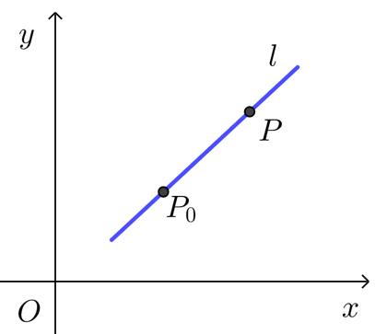
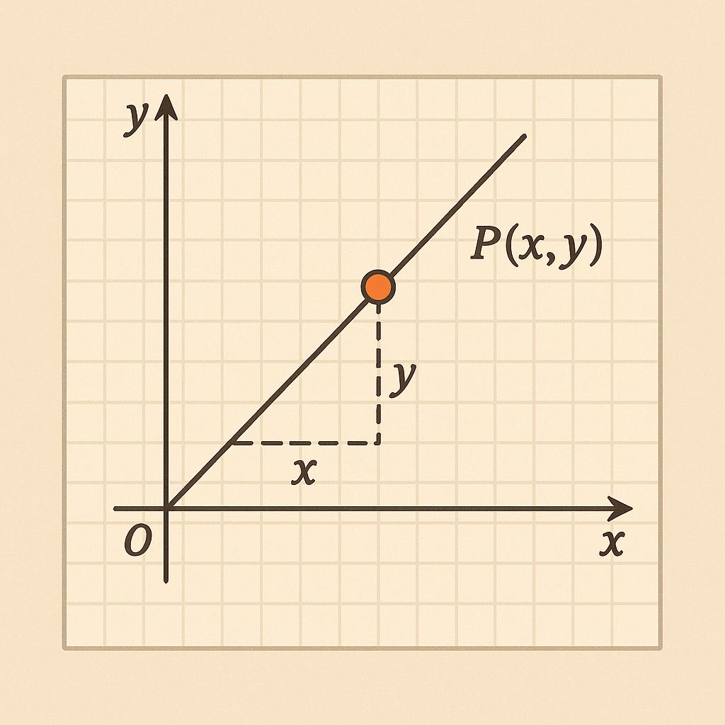
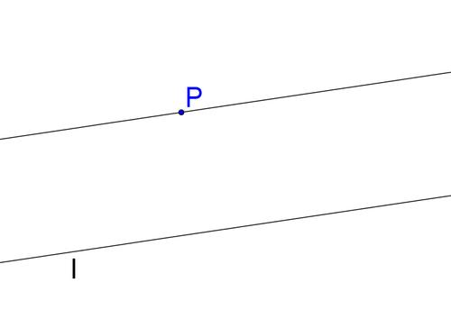

2. Point on a Line Segment
# Source: AI Source: Provided by: [Data Path: Persons Table -> ID Column: 1, Name_En Column: Motasem Essam] -> From: [ChatGPT] on [7/25/2026]
A point is contained in a line segment if it lies between its endpoints or coincides with an endpoint.
For segment:
$$\overset{‾}{AB}$$
a point P is contained in the segment when:
$$\boxed{P∈\overset{‾}{AB}}$$
For example, if:
$$A=\left(0 , 0\right), B=\left(6 , 0\right)$$
then:
$$P=\left(3 , 0\right)$$
is contained in the segment:
$$\boxed{P∈\overset{‾}{AB}}$$
Both endpoints are also contained:
$$A∈\overset{‾}{AB}, B∈\overset{‾}{AB}$$

3. Point on a Ray
# Source: AI Source: Provided by: [Data Path: Persons Table -> ID Column: 1, Name_En Column: Motasem Essam] -> From: [ChatGPT] on [7/25/2026]
A point is contained in a ray if it lies on the ray starting from its endpoint and extending in its specified direction.
For ray:
$$\vec{AB}$$
a point P is contained in it when:
$$\boxed{P∈\vec{AB}}$$
The starting point A is included in the ray:
$$A∈\vec{AB}$$
but points on the opposite extension beyond A are not contained in the ray.

4. Point in a Plane
# Source: AI Source: Provided by: [Data Path: Persons Table -> ID Column: 1, Name_En Column: Motasem Essam] -> From: [ChatGPT] on [7/25/2026]
A point is contained in a plane if its coordinates satisfy the plane equation.
For example, consider:
$$Π:x+2y+z=10$$
and:
$$P=\left(2 , 3 , 2\right)$$
Substitute:
$$2+2\left(3\right)+2=10 \\ 10=10$$
Therefore:
$$\boxed{P∈Π}$$
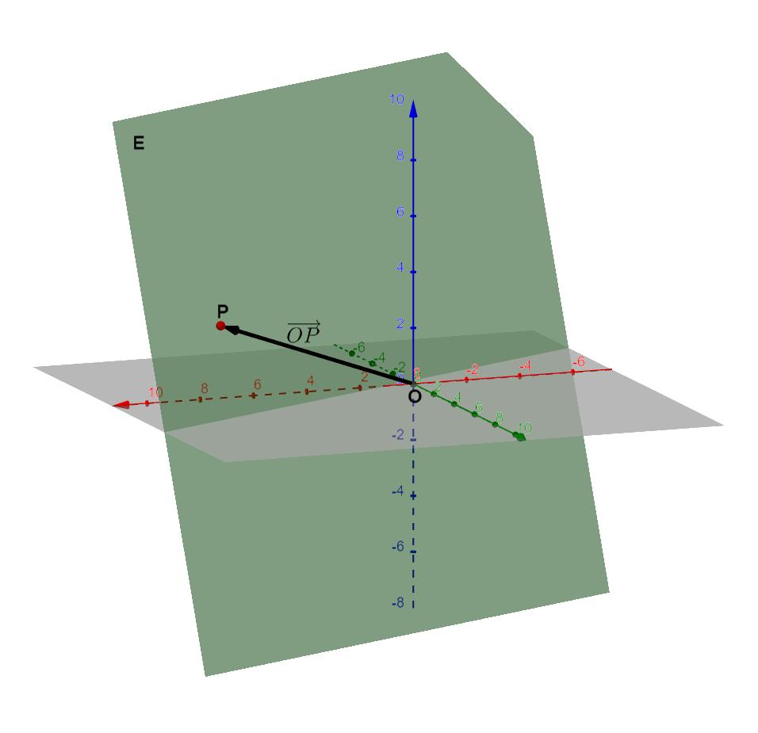
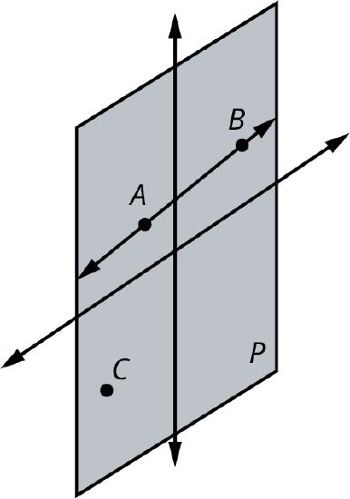
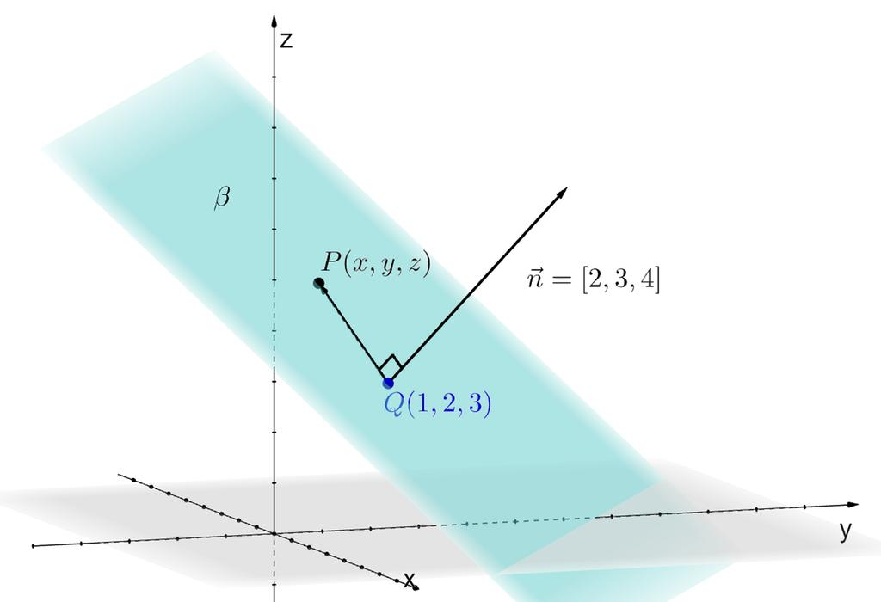
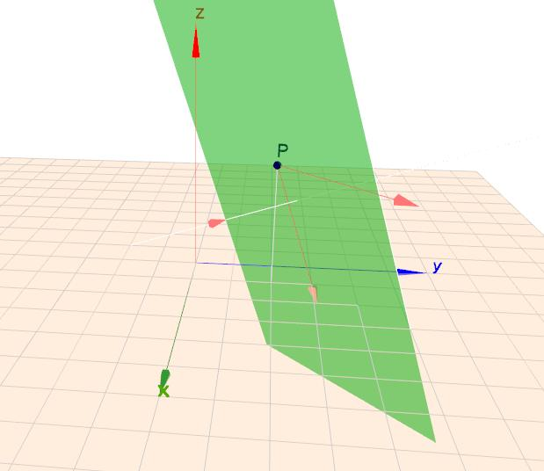
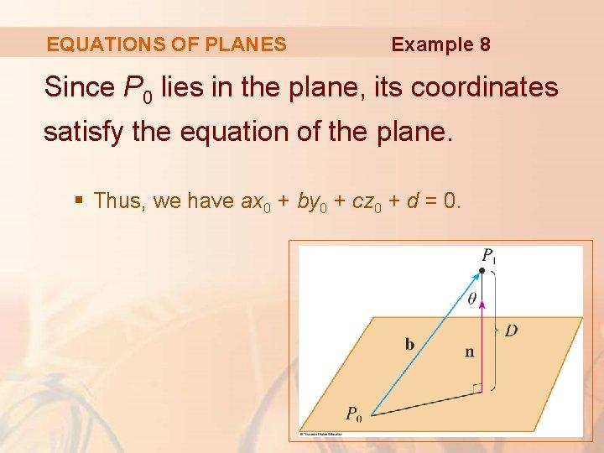

5. Point Inside a Region
# Source: AI Source: Provided by: [Data Path: Persons Table -> ID Column: 1, Name_En Column: Motasem Essam] -> From: [ChatGPT] on [7/25/2026]
A point can be contained inside a two-dimensional region.
For a circular disk centered at the origin:
$$D:x^{2}+y^{2}≤r^{2}$$
a point P=(x,y) is contained in the disk if:
$$\boxed{x^{2}+y^{2}≤r^{2}}$$
For example, if:
$$r=5$$
and:
$$P=\left(3 , 4\right)$$
then:
$$3^{2}+4^{2}=9+16=25$$
so:
$$25≤25$$
Therefore:
$$\boxed{P∈D}$$

6. Point on a Surface
# Source: AI Source: Provided by: [Data Path: Persons Table -> ID Column: 1, Name_En Column: Motasem Essam] -> From: [ChatGPT] on [7/25/2026]
In three-dimensional geometry, a point can belong to a surface.
For a sphere centered at the origin:
$$x^{2}+y^{2}+z^{2}=r^{2}$$
a point satisfying this equation lies on the spherical surface.
For example:
$$r=5$$
and:
$$P=\left(3 , 4 , 0\right)$$
Then:
$$3^{2}+4^{2}+0^{2}=25$$
Therefore:
$$\boxed{P∈S}$$
where S is the spherical surface.

7. Point Inside a Solid
# Source: AI Source: Provided by: [Data Path: Persons Table -> ID Column: 1, Name_En Column: Motasem Essam] -> From: [ChatGPT] on [7/25/2026]
A point can be contained within a three-dimensional solid.
For a solid sphere:
$$B:x^{2}+y^{2}+z^{2}≤r^{2}$$
a point belongs to the solid if:
$$\boxed{x^{2}+y^{2}+z^{2}≤r^{2}}$$
For example, with:
$$r=5$$
and:
$$P=\left(1 , 2 , 2\right)$$
we have:
$$1^{2}+2^{2}+2^{2}=1+4+4=9$$
and:
$$9<25$$
Therefore, the point lies inside the sphere:
$$\boxed{P∈B}$$

Mathematical Representation
# Source: AI Source: Provided by: [Data Path: Persons Table -> ID Column: 1, Name_En Column: Motasem Essam] -> From: [ChatGPT] on [7/25/2026]
Point containment is generally represented using the element-of symbol:
$$\boxed{∈}$$
Point belongs to object
$$P∈G$$
Point does not belong to object
$$P∉G$$
For a geometric object represented as a set:
$$G=\left\{P∣P\text{ satisfies a specified condition}\right\}$$
point containment means that the point satisfies that condition.

Point Containment in Coordinate Geometry
# Source: AI Source: Provided by: [Data Path: Persons Table -> ID Column: 1, Name_En Column: Motasem Essam] -> From: [ChatGPT] on [7/25/2026]
Coordinate equations provide a direct method for testing point containment.

Line
# Source: AI Source: Provided by: [Data Path: Persons Table -> ID Column: 1, Name_En Column: Motasem Essam] -> From: [ChatGPT] on [7/25/2026]
For:
$$ax+by=c$$
point:
$$P=\left(x_{0} , y_{0}\right)$$
belongs to the line if:
$$ax_{0}+by_{0}=c$$

Plane
# Source: AI Source: Provided by: [Data Path: Persons Table -> ID Column: 1, Name_En Column: Motasem Essam] -> From: [ChatGPT] on [7/25/2026]
For:
$$ax+by+cz=d$$
point:
$$P=\left(x_{0} , y_{0} , z_{0}\right)$$
belongs to the plane if:
$$ax_{0}+by_{0}+cz_{0}=d$$

Circle
# Source: AI Source: Provided by: [Data Path: Persons Table -> ID Column: 1, Name_En Column: Motasem Essam] -> From: [ChatGPT] on [7/25/2026]
For:
$${\left(x-h\right)}^{2}+{\left(y-k\right)}^{2}=r^{2}$$
a point belongs to the circle if:
$${\left(x_{0}-h\right)}^{2}+{\left(y_{0}-k\right)}^{2}=r^{2}$$

Disk
# Source: AI Source: Provided by: [Data Path: Persons Table -> ID Column: 1, Name_En Column: Motasem Essam] -> From: [ChatGPT] on [7/25/2026]
For:
$${\left(x-h\right)}^{2}+{\left(y-k\right)}^{2}≤r^{2}$$
a point belongs to the disk if:
$${\left(x_{0}-h\right)}^{2}+{\left(y_{0}-k\right)}^{2}≤r^{2}$$

Sphere
# Source: AI Source: Provided by: [Data Path: Persons Table -> ID Column: 1, Name_En Column: Motasem Essam] -> From: [ChatGPT] on [7/25/2026]
For:
$${\left(x-h\right)}^{2}+{\left(y-k\right)}^{2}+{\left(z-l\right)}^{2}=r^{2}$$
a point belongs to the spherical surface if:
$${\left(x_{0}-h\right)}^{2}+{\left(y_{0}-k\right)}^{2}+{\left(z_{0}-l\right)}^{2}=r^{2}$$

Point Containment in a Polygon
# Source: AI Source: Provided by: [Data Path: Persons Table -> ID Column: 1, Name_En Column: Motasem Essam] -> From: [ChatGPT] on [7/25/2026]
A point can also be tested to determine whether it lies inside a polygon.
For a polygonal region, there are three possibilities:
- Point is inside the polygon.
- Point is on the boundary.
- Point is outside the polygon.
For a closed polygonal region R:
$$P∈R$$
means that the point is contained in the region.
Point-in-polygon algorithms are widely used in computational geometry and computer graphics.
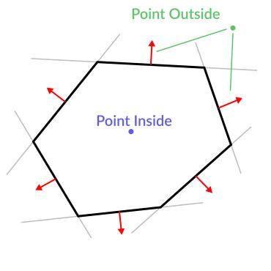
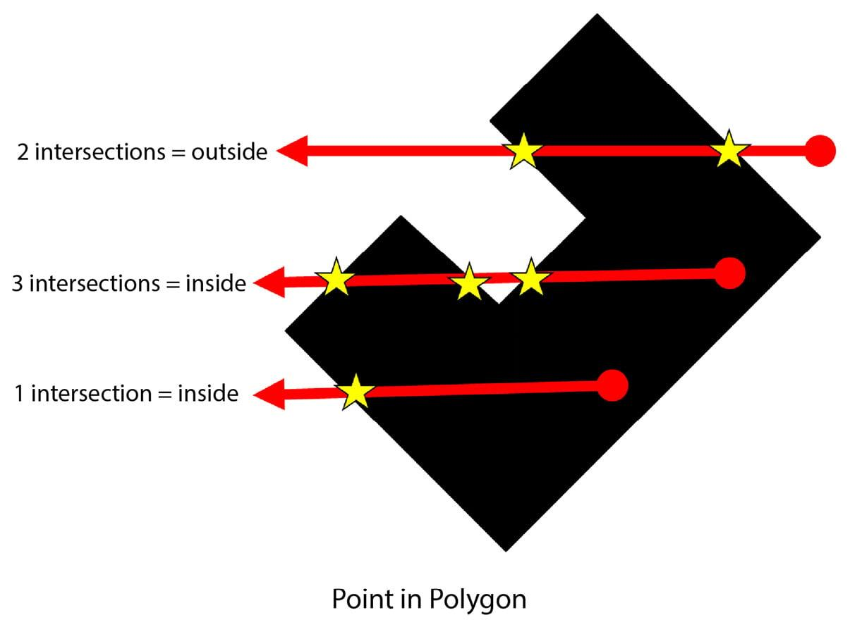
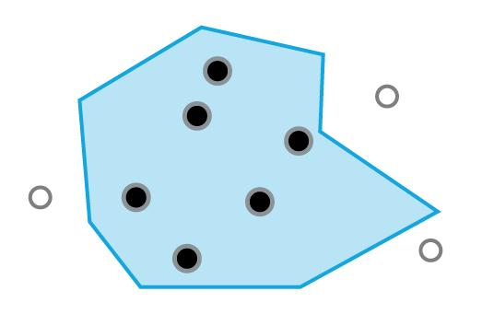
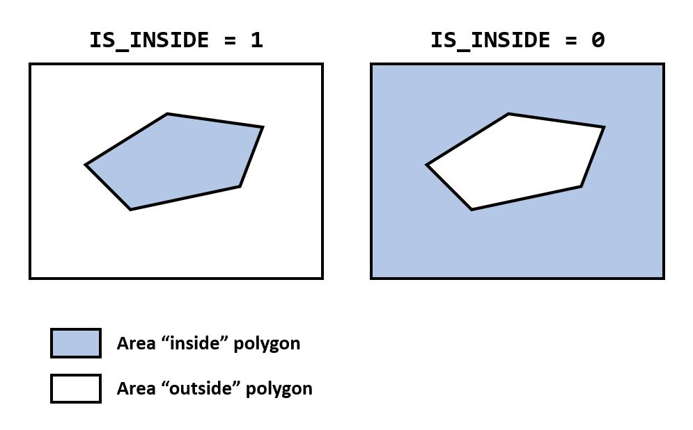

Point Containment and Boundary
# Source: AI Source: Provided by: [Data Path: Persons Table -> ID Column: 1, Name_En Column: Motasem Essam] -> From: [ChatGPT] on [7/25/2026]
A particularly important distinction is:
$$\boxed{\text{Containment}≠\text{Interior containment}}$$
If:
$$P∈R$$
the point may be inside the region or on its boundary, depending on how R is defined.
For a closed disk:
$$D=\left\{\left(x , y\right):x^{2}+y^{2}≤r^{2}\right\}$$
a boundary point is contained:
$$P∈D$$
because equality is allowed.
For the open disk:
$$D^{∘}=\left\{\left(x , y\right):x^{2}+y^{2}<r^{2}\right\}$$
a boundary point is not contained:
$$P∉D^{∘}$$

Point Containment vs Point Intersection
# Source: AI Source: Provided by: [Data Path: Persons Table -> ID Column: 1, Name_En Column: Motasem Essam] -> From: [ChatGPT] on [7/25/2026]
These terms should be distinguished.
Point containment
A point belongs to another object:
$$\boxed{P∈G}$$
Intersection
Two geometric objects share one or more points:
$$\boxed{A∩B≠∅}$$
For example, if point P lies on line l, we say:
$$P∈l$$
We do not normally describe this as an "intersection" between a point and a line.
However, if two lines l_1 and l_2 meet at P:
$$l_{1}∩l_{2}=\left\{P\right\}$$
then P is their point of intersection.

Point Containment vs Coincidence
# Source: AI Source: Provided by: [Data Path: Persons Table -> ID Column: 1, Name_En Column: Motasem Essam] -> From: [ChatGPT] on [7/25/2026]
A point and another point can be coincident.
If:
$$P=Q$$
then they represent the same point.
But if a point lies on a line:
$$P∈l$$
this is a containment/membership relationship, not coincidence between the point and line.
Therefore:
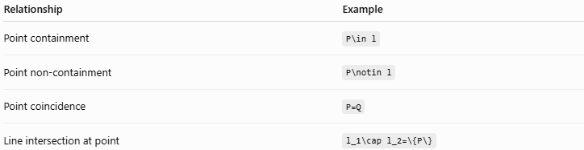
Relationship | Example
Point containment | P\in l
Point non-containment | P\notin l
Point coincidence | P=Q
Line intersection at point | l_1\cap l_2=\{P\}

Examples

Example 1 – Point on a Line
# Source: AI Source: Provided by: [Data Path: Persons Table -> ID Column: 1, Name_En Column: Motasem Essam] -> From: [ChatGPT] on [7/25/2026]
Determine whether:
$$P=\left(4 , 9\right)$$
lies on:
$$y=2x+1$$
Substitute:
$$9=2\left(4\right)+1 \\ 9=9$$
Therefore:
$$\boxed{P∈l}$$

Example 2 – Point Inside a Circle
# Source: AI Source: Provided by: [Data Path: Persons Table -> ID Column: 1, Name_En Column: Motasem Essam] -> From: [ChatGPT] on [7/25/2026]
Consider:
$$x^{2}+y^{2}≤100$$
and:
$$P=\left(6 , 8\right)$$
Then:
$$6^{2}+8^{2}=36+64=100$$
Therefore, the point is on the boundary and is still contained in the closed disk:
$$\boxed{P∈D}$$
but:
$$P∉int⁡\left(D\right)$$

Example 3 – Point Outside a Circle
# Source: AI Source: Provided by: [Data Path: Persons Table -> ID Column: 1, Name_En Column: Motasem Essam] -> From: [ChatGPT] on [7/25/2026]
Consider:
$$x^{2}+y^{2}≤25$$
and:
$$P=\left(4 , 4\right)$$
Then:
$$4^{2}+4^{2}=16+16=32$$
Since:
$$32>25$$
the point is outside:
$$\boxed{P∉D}$$

Example 4 – Point on a Plane
# Source: AI Source: Provided by: [Data Path: Persons Table -> ID Column: 1, Name_En Column: Motasem Essam] -> From: [ChatGPT] on [7/25/2026]
Consider:
$$2x-y+z=5$$
and:
$$P=\left(2 , 1 , 2\right)$$
Substitute:
$$2\left(2\right)-1+2=5 \\ 5=5$$
Therefore:
$$\boxed{P∈Π}$$

Relationship with Related Concepts
# Source: AI Source: Provided by: [Data Path: Persons Table -> ID Column: 1, Name_En Column: Motasem Essam] -> From: [ChatGPT] on [7/25/2026]
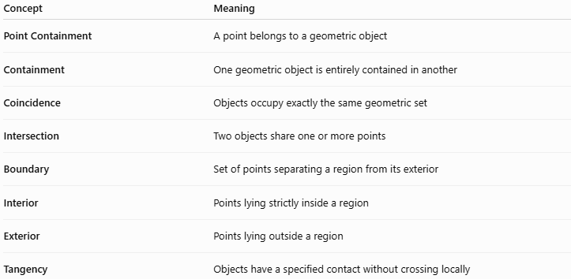
Concept | Meaning
Point Containment | A point belongs to a geometric object
Containment | One geometric object is entirely contained in another
Coincidence | Objects occupy exactly the same geometric set
Intersection | Two objects share one or more points
Boundary | Set of points separating a region from its exterior
Interior | Points lying strictly inside a region
Exterior | Points lying outside a region
Tangency | Objects have a specified contact without crossing locally

Important Special Case: Point as the Smallest Geometric Object
# Source: AI Source: Provided by: [Data Path: Persons Table -> ID Column: 1, Name_En Column: Motasem Essam] -> From: [ChatGPT] on [7/25/2026]
A point has no length, width, or thickness.
It is represented by coordinates such as:
$$P=\left(x , y\right)$$
in two-dimensional space, or:
$$P=\left(x , y , z\right)$$
in three-dimensional space.
Because geometric objects are sets of points, point containment forms the foundation for many other geometric relationships.
For example:
$$P∈l$$
means the point belongs to the line.
A segment can then be viewed as a set of points:
$$\overset{‾}{AB}=\left\{P∣P\text{ lies between }A\text{ and }B\right\}$$
and a region can similarly be defined as a set of points satisfying particular conditions.

Real-World Applications
# Source: AI Source: Provided by: [Data Path: Persons Table -> ID Column: 1, Name_En Column: Motasem Essam] -> From: [ChatGPT] on [7/25/2026]
Point containment is used in:
- Computer graphics – determining whether a pixel or point lies inside a shape.
- CAD – checking whether a coordinate belongs to a geometric feature.
- GIS – determining whether a location lies inside a geographical region.
- Robotics – determining whether a robot position lies within an allowed workspace.
- Architecture – checking whether points lie inside structural boundaries.
- Engineering – testing whether measured coordinates lie on designed surfaces.
- Computer-aided manufacturing – determining whether tool positions remain within permitted regions.
- Navigation – determining whether a location lies within a specified area.

Advantages
# Source: AI Source: Provided by: [Data Path: Persons Table -> ID Column: 1, Name_En Column: Motasem Essam] -> From: [ChatGPT] on [7/25/2026]
- Simple and precise mathematical relationship.
- Provides the foundation for geometric set descriptions.
- Easy to test using coordinates and equations.
- Applies to both 2D and 3D geometry.
- Useful in computational geometry.
- Helps distinguish inside, boundary, and outside positions.

Limitations
# Source: AI Source: Provided by: [Data Path: Persons Table -> ID Column: 1, Name_En Column: Motasem Essam] -> From: [ChatGPT] on [7/25/2026]
- Point containment depends on how the containing object is defined.
- Boundary conventions can affect whether a point is considered contained.
- Visual inspection alone may not be sufficient for complicated shapes.
- For irregular regions, determining containment may require specialized algorithms.

Key Points
# Source: AI Source: Provided by: [Data Path: Persons Table -> ID Column: 1, Name_En Column: Motasem Essam] -> From: [ChatGPT] on [7/25/2026]
- Point Containment describes a point belonging to a geometric object.
- Its fundamental notation is:
$$\boxed{P∈G}$$
- Non-containment is:
$$\boxed{P∉G}$$
- A point can belong to a line, segment, ray, plane, region, surface, or solid.
- For equations, containment can usually be tested by substitution.
- A point can be inside, on the boundary, or outside a region.
- Boundary containment depends on whether the region includes its boundary.
- Point containment is a membership relationship, not normally an intersection relationship.
- It is a fundamental subtype of:
$$\boxed{\text{Geometric Containment}}$$

Conclusion
# Source: AI Source: Provided by: [Data Path: Persons Table -> ID Column: 1, Name_En Column: Motasem Essam] -> From: [ChatGPT] on [7/25/2026]
Point Containment is the most fundamental type of geometric containment. It describes whether a point belongs to a larger geometric object, expressed mathematically as P\in G. The containing object may be a line, segment, ray, plane, region, surface, or solid. In coordinate geometry, point containment can often be determined by substituting the point's coordinates into an equation or inequality. The distinction between inside, boundary, and outside is particularly important when dealing with geometric regions.

